**Course: Advance Bio Informatics**

**Module Title: Drug Discovery Applications**

**Module No:115**

**Areas Influencing DD**

In this module, we present some areas which have direct effect on the drug discovery mechanism. Following areas are discussed here, though list can be extended to several other areas.

* Molecular Biology on Drug Discovery
* High-Throughput Screening
* Combinatorial Chemistry

**Molecular Biology:** is the branch of biology that deals with the molecular basis of biological activity. This field overlaps with other areas of biology and chemistry, particularly genetics and biochemistry. Molecular biology chiefly concerns itself with understanding the interactions between the various systems of a cell, including the interactions between the different types of DNA, RNA and protein biosynthesis as well as learning how these interactions is regulated. It directly influences Genetic information, biochemical and chemical terms which further have effects on the drug discovery process.

**High Throughput Screening:** HTS is a method for scientific experimentation especially used in drug discovery and relevant to the fields of biology and chemistry. Using robotics, data processing and control software, liquid handling devices, and sensitive detectors, High-throughput screening allows a researcher to quickly conduct millions of chemical, genetic, or pharmacological tests. Through this process one can rapidly identify active compounds, antibodies, or genes that modulate a particular biomolecular pathway. The results of these experiments provide starting points for drug design and for understanding the interaction or role of a particular biochemical process in biology.

Widely used in the pharmaceutical industry.

**HTS Robot**

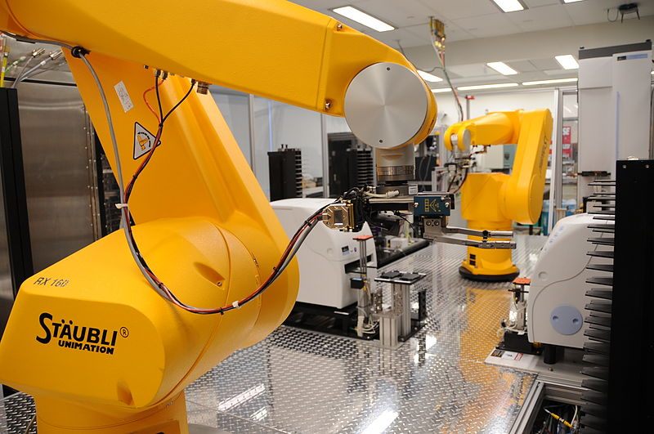

**Combinatorial Chemistry:** Combinatorial chemistry comprises chemical synthetic methods that make it possible to prepare a large number (tens to thousands or even millions) of compounds in a single process. These compound libraries can be made as mixtures, sets of individual compounds or chemical structures generated in silicon. Combinatorial chemistry can be used for the synthesis of small molecules and for peptides.

Strategies that allow identification of useful components of the libraries are also part of combinatorial chemistry. The methods used in combinatorial chemistry are applied outside chemistry, too.

